Flask-Migrate
Flask-Migrate is an extension that handles SQLAlchemy database migrations for Flask applications using Alembic. The database operations are made available through the Flask command-line interface.
## Install Flask-Migrate with pip (if not ready installed)
pip install Flask-Migrate
## Usage
- To create an empty migration script:
$ flask db revision -m 'add description migration'
- To create a migration script, with autogenerated changes (computed between SQLAlchemy models declared in the Flask app ( revision identifiers, used by Alembic) and the database the app points to ( in the Alembic_version table ).
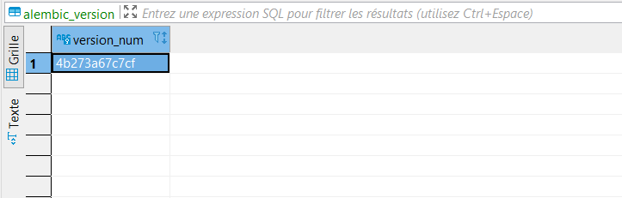

$ flask db migrate -m 'add description migration'
The migration script needs to be reviewed and edited, as Alembic currently does not detect every change you make in models. In particular, Alembic is currently unable to detect table name changes, column name changes, or anonymously named constraints.
## Then you can apply the migration to the database:
To upgrade the database by running every script from the database current version to the specified revision:
$ flask db upgrade ‘add specified version’
$ flask db upgrade f5b647
Or execute all migration from the database current version to the to the last migration generate in model
$ flask db upgrade f5b647
## To get the SQL scripts without executing the upgrade :
$ flask db upgrade f5b647 --sql
## To see all the commands that are available run this command:
$ flask db --help

